DEPARTMENT OF COMPUTER ENGINEERING OBJECT ORIENTED PROGRAMMING II DESIGN PROJECT REPORT



Online Book Store

Melike İrem GÜLER 152120161069

Tuçe Maide TEKEŞ 152120161015

Veysel Karani ÖZ 152120151099

Eskişehir

Introduction:

The online book store is a desktop application that offers books,music and magazine products to customers.

The user can listen to the first 7 seconds of the music CDs.

They can access the information of books and magazines.

User can register to the system , add products to the shopping cart and pay them in cash or credit card.

Customers are informed with an e-mails after receiving their products.

The user can change his / her password and update his / her information if he / she wants.

In the project, product information, user information and the products in the shopping cart are stored in the database.(sqLite)

For user security, passwords are encrypted and stored in the database.

There is one admin entry in the project.Admin can see users who have registered to the system, add products and update inventory information.

Design:

We used two design patterns in this project. One of them is Singleton Pattern and the other one is Observer Pattern. Singleton Pattern was used for database management and admin user. Observer pattern was used to inform the customer about the current inventory status.

As can be seen in UML, the book, music CD and magazine classes were inherited from the product class and the admin user class was inherited from the customer class.

As shown in Picture 1 , the products are included in flowlayout. The purpose of this form grows and shrinks according to the size of the products.

At the top of the form there are buttons attached to the panel.

Clicking the login button opens the login window .As you can see in Picture 2. if the password is the same as the hashed password kept in the database, user can enter into the system, and some buttons whose visibility turned off will be visible.

The user can click the info icon to examine the products. When it is clicked, a new form opens and the information in the database of the related product will be shown.( Picture 16)

when the user clicks the Play icon which resides on the music CD panels, a sample song is played for 7 seconds .

Customers can add products by pressing “+” symbol to their carts. Also, Cart button shows the number of added products by its design.( Picture 4)

When products are added to the cart, they are also added to the database with the customer ID. By doing so, we give customers ability to continue where they left off.

When the products are approved, a new form opens and payment information is entered in this form.(Picture 5,6)

When you press the buy button, the invoice is displayed in a new form.(Picture 8)

If admin is online, the admin form opens .The admin form also has buttons for adding products , customer list,updating inventory.(Picture 10)

If you click to add a new product button, the Add Product form opens.You can choose which product will be added with the help of radio buttons. If you can fill all the information of the product correctly, it can be added to the database.(Picture 12)

When the customer button is clicked, customers 'information is retrieved from the database and shown in the datagridview.(Picture 11)

If the file stock button is clicked ,Id ,name, type and stock information of the products are retrieved from the database and shown in the datagirdview. (Picture 13)

if the user wants to register, he/she should click on the log Up button and enter the required information to register.(Picture 14)

1) the first time the program will open.

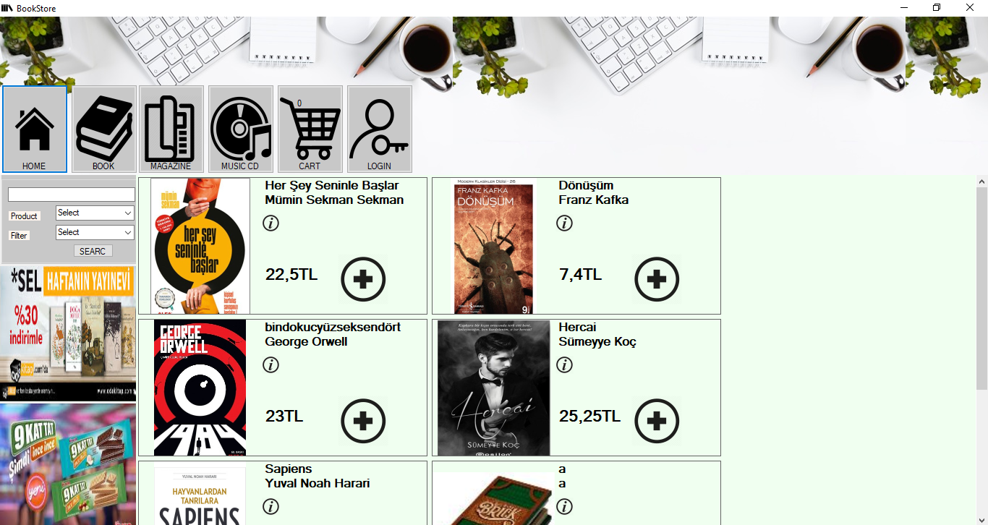

2) View Login Form

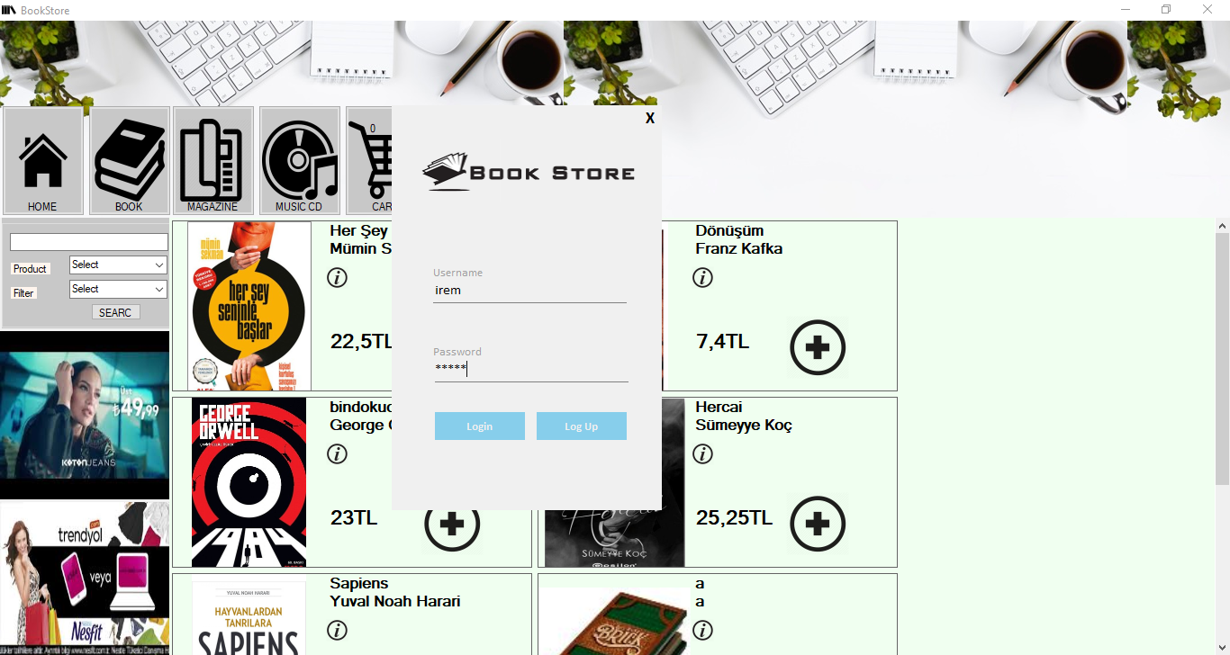

3) View Change Password

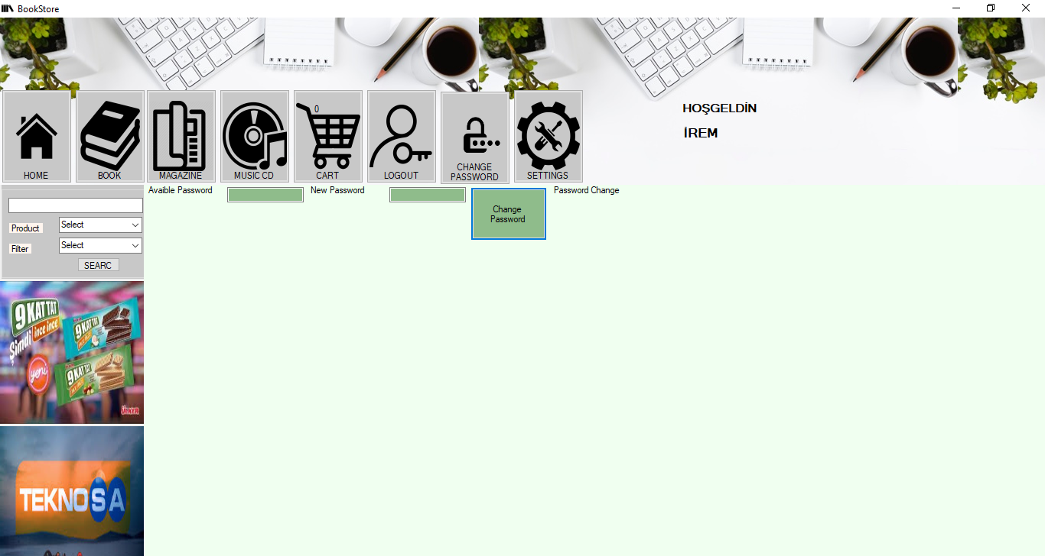

4) 3 products added to the basket after entering the system

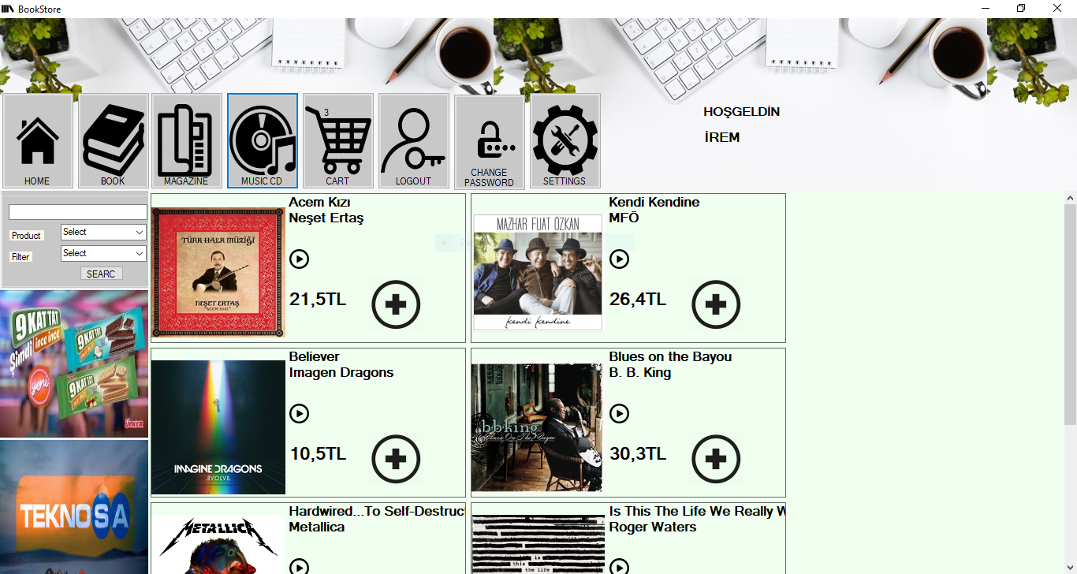

5) View Shopping cart

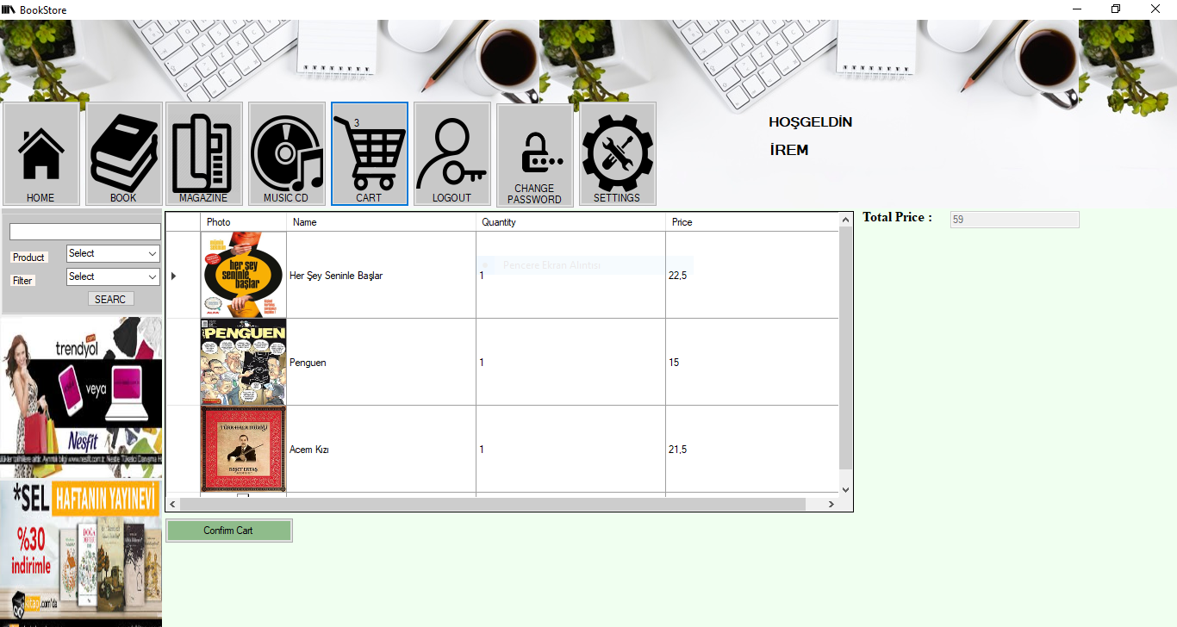

6) View Payment Form

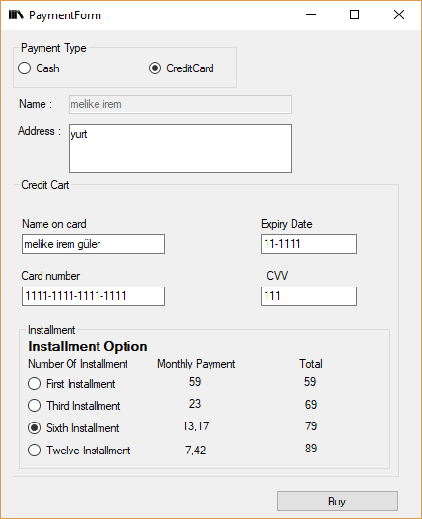

7)

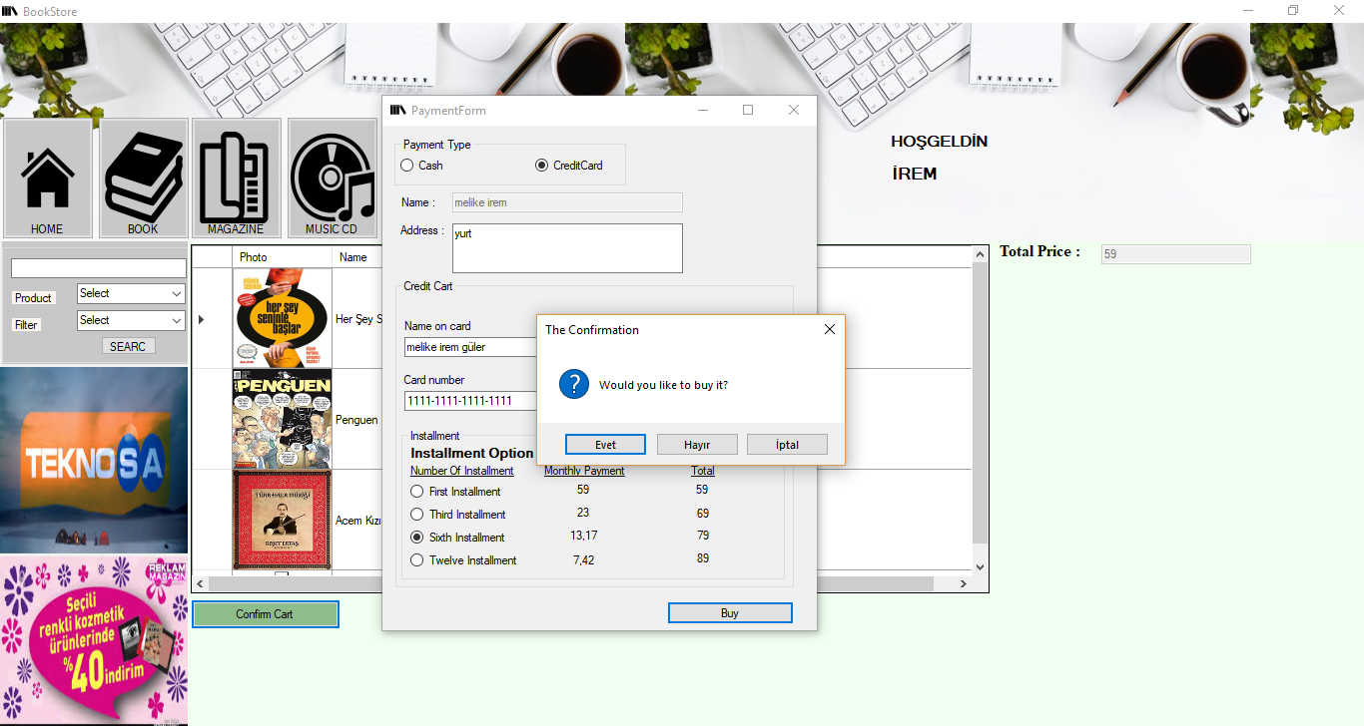

8) View Invoice Form

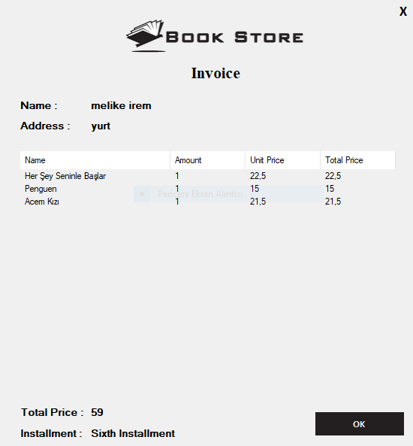

9) Send the invoice by email

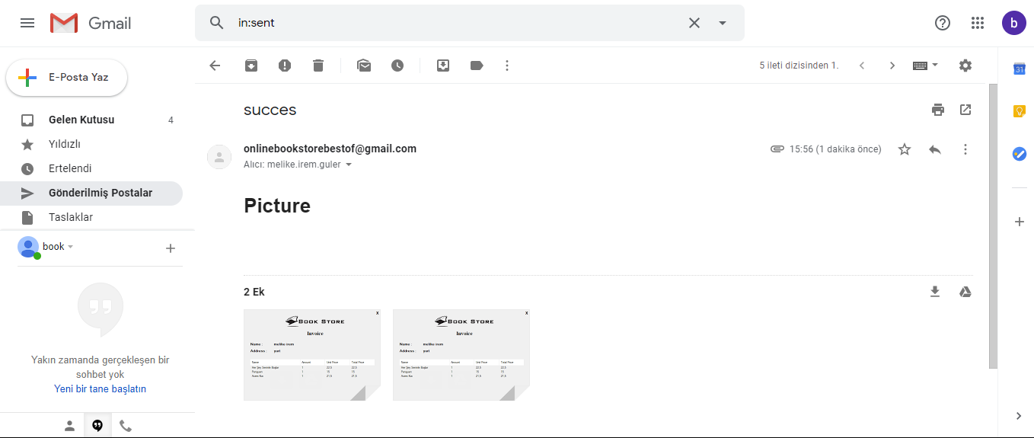

10)View Admin Form

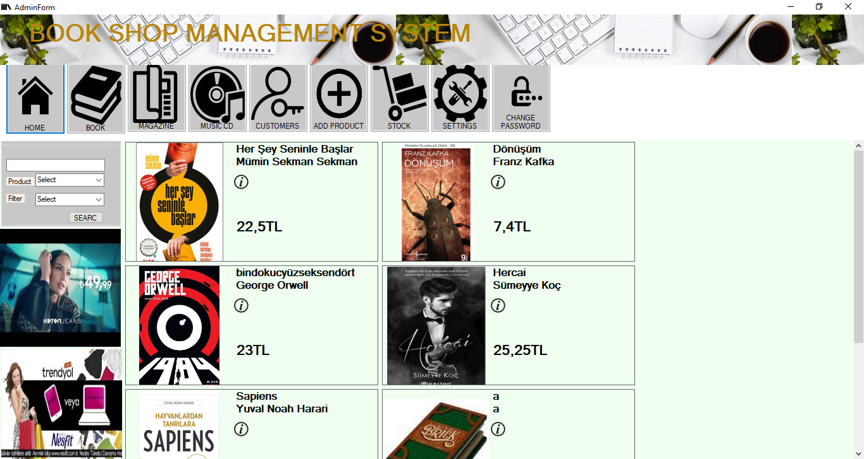

11)View Customers

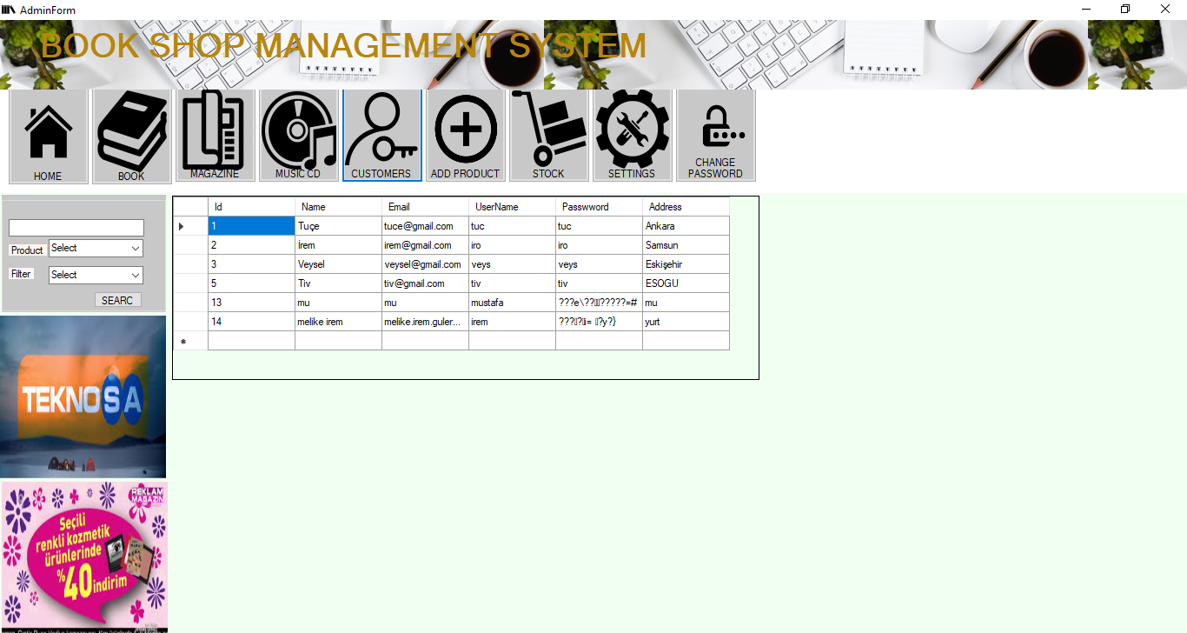

12)View Add Product Form

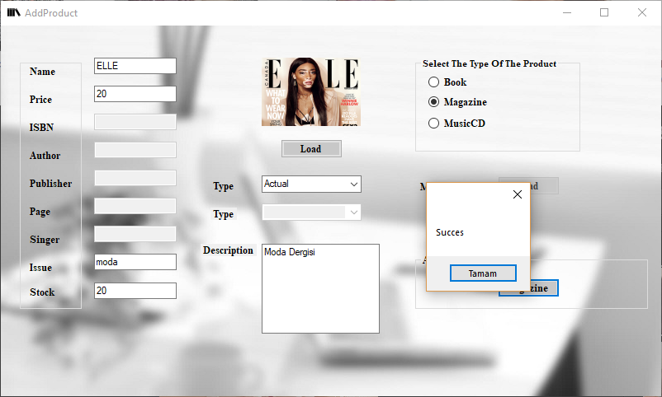

13)View Stock

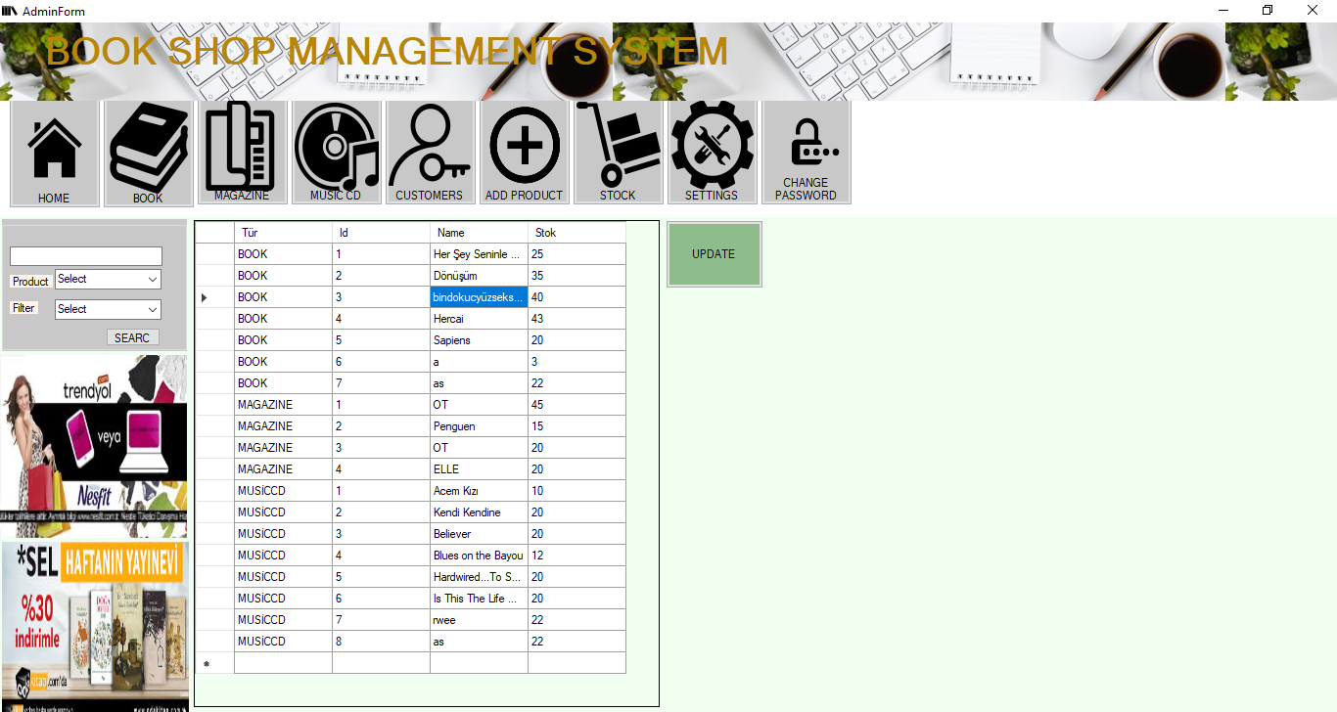

14)View Log up Form 15)View Setting Form

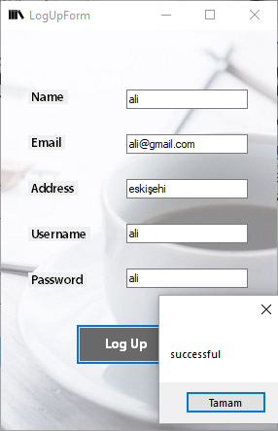 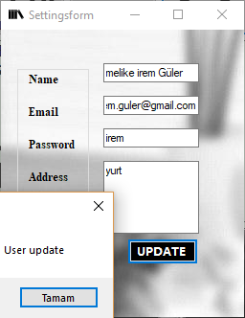

16)View Info Form

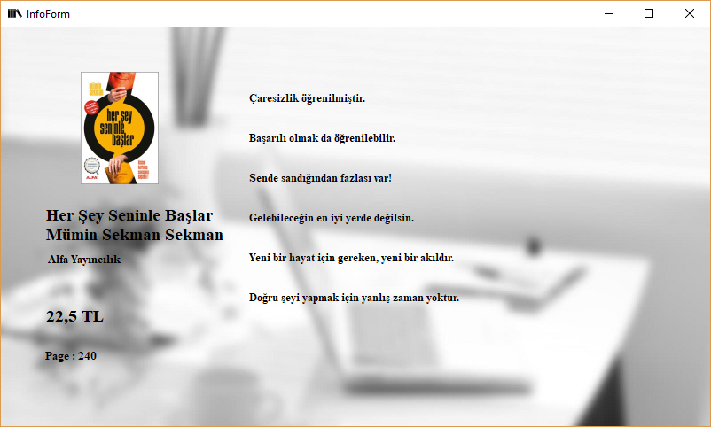

3) Duty of your team members

|  |  |  |
| --- | --- | --- |
| Veysel Karani ÖZ | Tuçe Maide TEKEŞ | Melike İrem GÜLER |
| Shopping Cart | Customer Form | Info Form |
| Database Class | Stok update | Admin Form |
| Invoice Form | Setting Form | Customer Form |
| Payment Form | Customer Lİst | Hash Password |
| Log in Form | Password Change | Send Email |
| Doxygen | Search | Log up Form |
|  | Database Class | Add product Form |
| %32 | %33 | %35 |

UML into the Project. (Class Diagram)

Github: https://github.com/melikeiremguler/guldurmeyenhoca.git